📂 Portfolio Case Study: The Automated Weather Reporter
Project Type: Enterprise Application Integration (EAI) / Automation
Platform: SAP Integration Suite (Cloud Integration)
Role: Integration Developer
1. Executive Summary
Designed and deployed an end-to-end integration flow ("iFlow") to automate the retrieval and distribution of real-time meteorological data. The system eliminates manual data checking by autonomously fetching live weather conditions for Harare, Zimbabwe, at 08:00 AM daily and delivering a formatted email report to end-users.
2. Technical Architecture
- Trigger: Timer Event (Scheduled Daily).
- Source System: Open-Meteo REST API (External Public API).
- Target System: SMTP Mail Server (Email Notification).
- Data Formats: JSON (Input) => XML (Processing) => String/Text (Output).
- Key Adapters: HTTP (GET), Mail (SMTP).
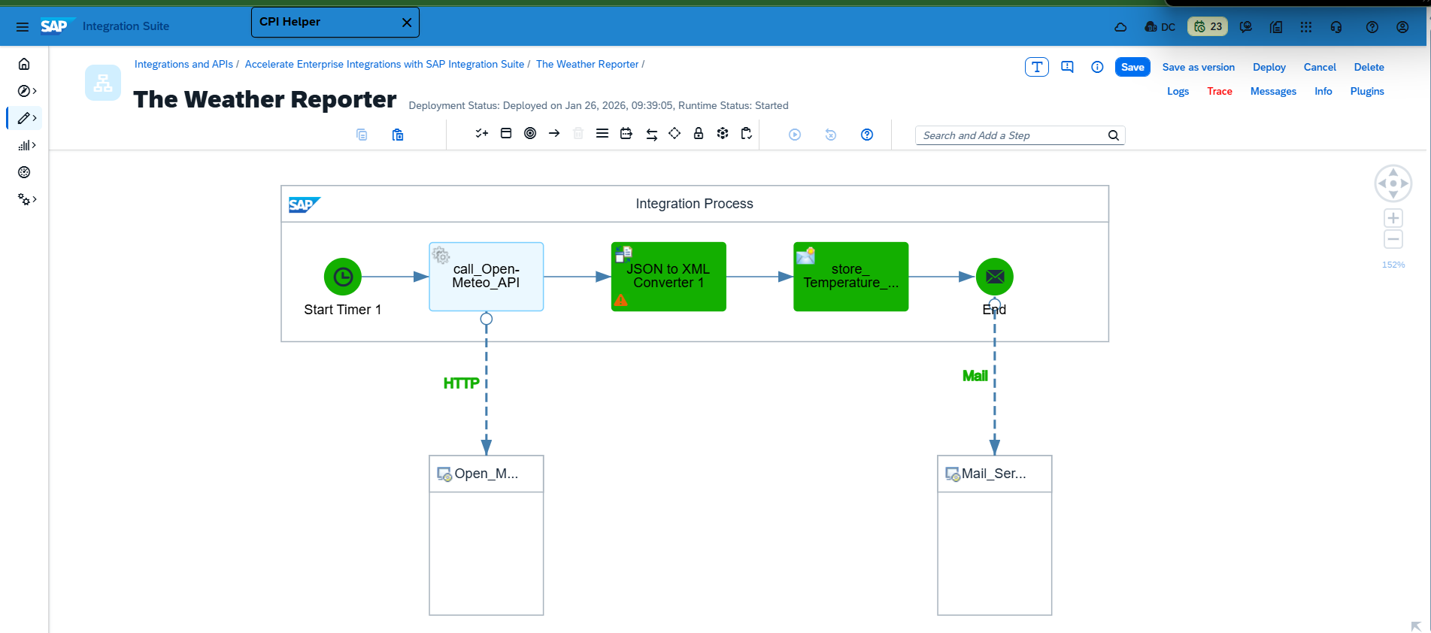
3. Implementation Logic
Step A: Data Ingestion (HTTP Adapter)
- Configured an HTTP GET request to the Open-Meteo API.
- API Endpoint: https://api.open-meteo.com/v1/forecast
- Query Parameters:
  - Defined precise coordinates for Harare (lat: -17.7781, long: 31.0894).
  - Crucial Logic: Appended &current_weather=true to force the API to return real-time data rather than just historical averages.
Step B: Transformation (JSON to XML Converter)
- Since the API returns JSON but SAP internal logic works best with XML, a conversion step was required.
- Root Element Strategy: Configured the converter to add a custom root tag (<root>) to handle JSON arrays validly and ensure a strict XML tree structure.
Step C: Content Enrichment (Content Modifier)
- Used XPath to parse the XML payload and extract specific nodes.
- Variable Extraction:
  - Property: temperature
  - XPath: /root/current_weather/temperature
- Message Body Construction: Dynamic injection of the extracted property into a user-friendly email body: "The temperature in Harare is ${property.temperature} °C degrees."
4. Challenges & Problem Solving
Demonstrating debugging capabilities and technical intuition.
- Challenge 1: The "Ghost Data" Issue
  - Issue: The integration ran successfully, but the email body was blank.
  - Diagnosis: Used Trace Mode to inspect the payload before processing. Discovered the JSON payload was missing the current_weather node because it was not explicitly requested in the URL.
  - Resolution: Updated the API query string to include &current_weather=true.
- Challenge 2: HTTP 400 Bad Request
  - Issue: The interface failed with a 400 status code.
  - Diagnosis: Analyzed the error logs and identified a syntax error in the query parameters (current=true instead of current_weather=true).
  - Resolution: Corrected the parameter syntax, validating the request via browser before redeploying.
- Challenge 3: JSON-to-XML Structure
  - Issue: Converting raw JSON resulted in invalid XML due to multiple top-level elements.
  - Resolution: Configured the converter to wrap the payload in a single <root> element to comply with XML standards.
5. Outcome
The project successfully established a robust, "set-and-forget" pipeline. It demonstrates proficiency in:
- Consuming external REST APIs.
- Manipulating complex data structures (JSON/XML).
- Using SAP Cloud Integration tracing tools for root-cause analysis.
- Scheduling and automation logic.

